Project

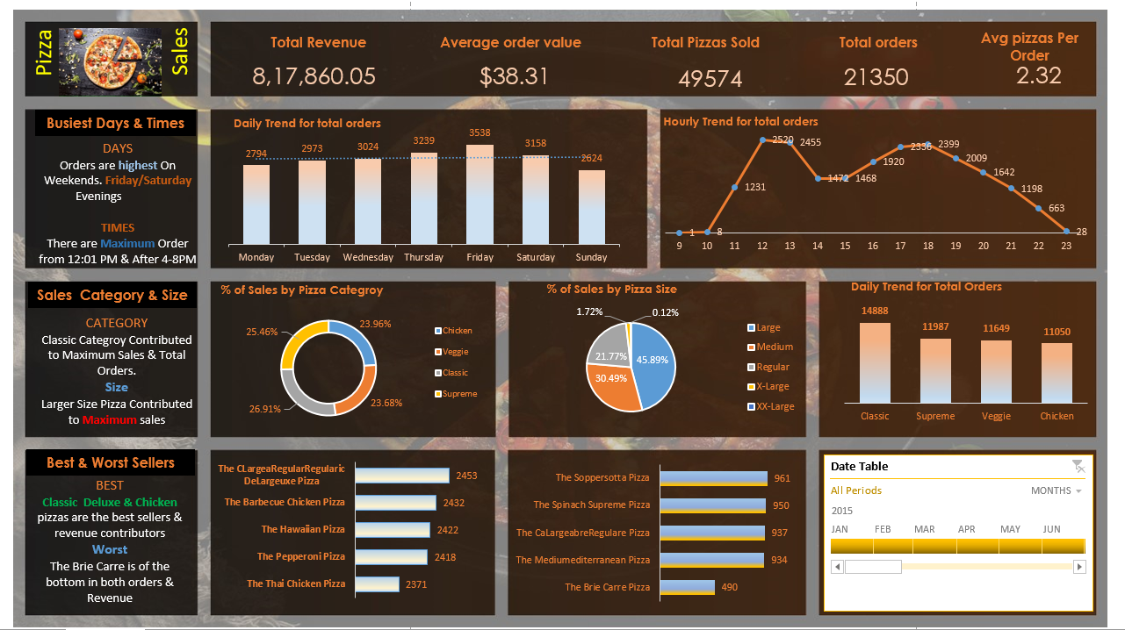

**SQL Queries to cross verify Excel Results**

select SUM(total_price)/count(Distinct order_id) as Average_order_Value from pizza_data

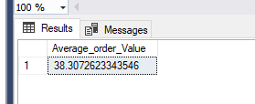

select SUM(quantity) as Total_Pizza_sold from Pizza_data

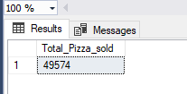

select SUM(quantity) as Total_Pizza_sold from Pizza_data

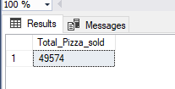

---Total Orders

Select distinct COUNT(order_id) as Total_orders from pizza_data

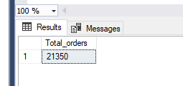

-------Average Pizzas per Order

Select Cast(Cast (SUM(quantity) as Decimal (10,2)) / Cast(count(distinct Order_ID) as decimal (10,2)) as Decimal(10,2)) as Avg_Pizzas_per_Order from Pizza_data

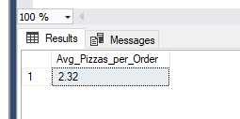

DW- Date of a Week which is used convert our order date into a string & will retrieve date Name

-----Dashboard--Deriving Charts Through SQL queries

---Daily Trend

Select DATENAME(DW,order_date) as Order_day,COUNT(Distinct Order_ID) as Total_Orders from Pizza_Data

Group by DATENAME(DW,order_date)

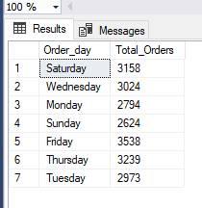

----Hourly Trend for total orders

select DATEPART(Hour,order_time) as Order_Hours,Count(distinct Order_id) as Total_sales from Pizza_data

Group by DATEPART(hour,order_time)

Order By DATEPART (hour,order_time)

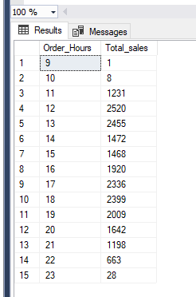

----Percentage of sales by pizza Category

select pizza_category,Sum(total_Price) as Total_sales,SUM(Total_price)*100/ (Select SUM(total_price) from pizza_data where MONTH(order_date)=1) as Percentage_sales from pizza_data

where MONTH(order_date)=1

Group by pizza_category

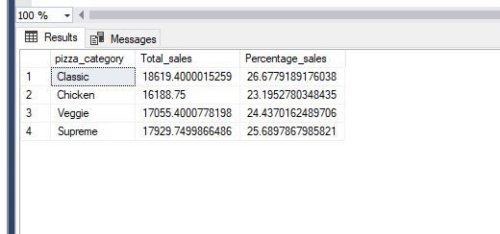

----------Percentage of sales by pizza Size

select pizza_Size,cast(Sum(total_Price) as decimal(10,2)) as Total_sales,cast(SUM(Total_price)*100/ (Select SUM(total_price) from pizza_data where MONTH(order_date)=1)

as decimal(10,2)) as Percentage_sales from pizza_data

where MONTH(order_date)=1

Group by pizza_Size order by Percentage_sales desc

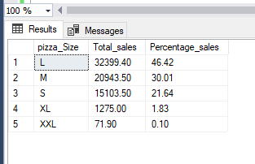

----Total Pizzas sold by pizza Category

select pizza_category,SUM(quantity) as total_pizzas_sold from pizza_data

Group by pizza_category

order by total_pizzas_sold desc

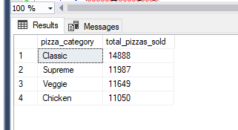

----Top 5 Pizza Names by sales

Select Top 5 pizza_name,SUM(quantity) as total_pizzas_sold from Pizza_data

Group by Pizza_name

order by total_pizzas_sold desc

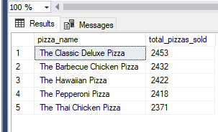

---Bottom 5 Pizza Names by sales

Select Top 5 pizza_name,SUM(quantity) as total_pizzas_sold from Pizza_data

Group by Pizza_name

order by total_pizzas_sold

